

**Savitribai Phule Pune University**



**Dr. D. Y. Patil Institute of Engineering, Management and Research, Akurdi, Pune – 44**

**2020-2021**

**Department of Electronics and Telecommunication Engineering**

Mini project Report on

**Cuffless Blood Pressure Monitoring Device**

**Submitted by:**

17. Sumitra Nandre

19. Om Dandade

21. Suyog Tarvate

**Under the Guidance of**

Dr. Priya Charles Prof. Dnyanda Hire



**Dr. D. Y. Patil Institute of Engineering, Management and Research, Akurdi, Pune – 44**

**2020 - 2021**

**Department of Electronics and Telecommunication Engineering**

CERTIFICATE

*This is to certify that Mr. Om Dandade, Mr. Sumitra Nandre and Mr. Suyog Tarvate of T.E. E&TC has successfully completed the Mini Project “Cuffless Blood Pressure Monitoring Device” Towards the partial fulfilment for the requirements of the Degree of Engineering course under the Savitribai Phule Pune University, Pune during the academic year 2020-2021.*

Prof. Dnyanda Hire Dr. Priya Charles

Project Guide H.O.D. E&TC

**DECLARATION**

We hereby declare that entire project work entitled “Cuffless Blood Pressure Monitoring Device” is a project report of Authentic work done by us and to the best of my knowledge and belief. No part of it has been submitted for any degree or diploma of any Institution previously. This Project work is submitted to Savitribai Phule Pune University, Pune in the Dr. D. Y. Patil Institute of Engineering, Management and Research, Akurdi, Pune during the academic year 2020-2021*.*

Date: 05-06-2021 Sumitra Nandre

Place: Akurdi, Pune. Om Dandade

Suyoug Tarvate

**ACKNOWLEDGEMENT**

We acknowledge our project guides**,** Prof. Dnyanda hire for the guidance and valuable suggestions during entire course of Mini project titled **“**Cuffless Blood Pressure Monitoring Device**”**

We also acknowledge with thanks to Dr. Priya Charles**,** head of the department of Electronics and Telecommunication Engineering for the support and providing facilities which helped us in the successful completion of this project.

Date: 05-06-2021 Sumitra Nandre

Place: Akurdi, Pune. Om Dandade

Suyoug Tarvate

**INDEX**

**Chapter No. Title Page No**

**ABSTRACT** iii

**LIST OF TABLES** iv

**LIST OF FIGURES** iv

**LIST OF SYMBOLS, ABBREVIATIONS** v

**1 INTRODUCTION** 1

1.1 General 1

1.2 Need for the study 2

1.3 About Technology and Principal used 2

1.4 Objective 3

**2 LITERATURE REVIEW** 4

2.1 Research paper I 4

2.2 Research paper II 5

2.3 Research paper III 6

2.4 Short description table 7

**3 PRINCIPALS** 8

3.1 General 8

3.2 Pulse Wave Velocity (PWV) and Pulse 8

Transit Time (PTT)

3.3 Working of PPG sensor 9

**4 METHODALOGY AND WORKING** 10

4.1 Flow of operation 10

4.2 Calculation of PTT 11

4.3 BP estimation using PTT 12

4.4 Calculation of constant Ki and BP 13

**5 DISCRIPTION** 14

5.1 Arduino UNO R3 14

5.1.1 Introduction 14

5.1.2 Physical characteristics 14

5.1.3 Summary 15

5.2 Photoplethysmogram (PPG) 16

5.2.1 Introduction 16

5.2.2 Features 17

5.2.3 Applications 17

5.2.4 Finger placement 17

5.2.4 Summary 18

5.3 LCD module 18

5.4 Push buttons 19

5.5 Battery 19

**6**  **EXPENDITURE INCURRED** 20

**7 SURVEY** 21

**8 ADVANTAGE, DISADVANTAGES AND** 24

**APPLICATION**

**9 CONCLUSION AND WORK SCHEDULED** 26

**FOR PHASE – II**

**10 REFERENCES** 27

**ABSTRACT**

A cuffless Blood Pressure Monitoring is a non-invasive (which don’t include injection/Inse­rtion of instrument in the body) method to measure diastolic and systolic blood pressure. the traditional methods which use an inflatable cuff to wrap around the arm is yet widely and mostly used method due to its accuracy. But because of the cuff, it limits the portability of device and make not useable for time-to-time BP (Blood Pressure) monitoring or live BP monitoring.

Recently wearable tech and smartphone health is becoming a widely used method of health monitoring, and you project adds a portable way of BP monitoring. Yet there are several methods has been discovered to estimate BP which includes PTT-based estimation, Pulse contour method, Tonometry, Acceleration PPG: second derivative analysis and other. Our project discussed and proposed around the PTT (Pulse Transit Time) base estimation.

Previously the researched been done for calculating BP using PTT-based technique, but most of them used machine learning and deep learning to calculate BP pressure, out project will do the same without using ML but will lose some accuracy. We are aimed to illustrate how accurate we can get without using ML, and so the project falls under Experimental based category. Which for now we will support by lot research and surveys available.

**LIST OF TABLES**

**Sr. No. Tables Page No.**

1 **Table 2.1.1**: Table for principles discussed 4

2 **Table 2.3.1**:short description table for literature review 7

3 **Table 5.1.1**:summary of Arduino 15

4 **Table 5.2.1** summary of PPG 18

5 **Table 6.1** Expenditure table 20

**LIST OF FIGURES**

**Sr. No. Figures Page No.**

1 **Figure 3.1.1** Layers in vessels 8

2 **Figure 3.2.1** Visualization of PWV 8

3 **Figure 3.2.2** plcement fo PPG sensor, 9

a) at elbow and writs,

b) at wrist and finger,

c) at 2 fingers of both hands

4 **Figure 3.3.1** 9

a) working of PPG,

b) standard output of PPG

5 **Figure 4.1.1** Block diagram of proposed system 10

6 **Figure 4.2.1** PTT calculation based on the PPG waveform 11

and ECG R wave

7 **Figure 4.2.2** PPT using PPG only 11

8 **Figure 4.4.1** Chart: Changing blood pressure with 13

changing height, weight and age

9 **Figure 5.1.1** Arduino UNO R3 front 14

10 **Figure 5.1.2** Arduino UNO R3 rear 15

11 **Figure 5.2.1** PPG sensor 16

12 **Figure 5.2.2** Finger placements 17

13 **Figure 5.3.1** LCD module 18

14 **Figure 5.4.1** Push button array 19

15 **Figure 5.5.1** Battery 19

16 **Figure 7.1** Survey results 21

17 **Figure 9.2.1** Smart ring and smart watch 26

**LIST OF SYMBOLS, ABBREVIATION**

**Sr. No Symbol/Abbreviation Meaning**

1 BP Blood Pressure

2 ABPM Ambulatory Blood Pressure Monitoring

3 NIBP Non-Invasive Blood Pressure

4 PWA Pulse Wave Analysis

5 PWV Pulse Wave Velocity

6 PAT Pulse Arrival Time

7 PTT Pulse Transit Time

8 PPG Photoplethysmogram

9 CPPTs Conventional PPTs

10 ECG Electro Cardio Graph

11 SBP Systolic Blood Pressure

12 DBP Diastolic Blood Pressure

13 MAE Mean Absolute Error

14 ADC Analogue to Digital Converter

**CHAPTER I**

**INTRODUCTION**

**1.1 General**

Blood pressure is one the physiological parameter which tells so much one’s health condition. That being said not maintaining good BP (Blood Pressure) level specifically having higher level (known as Hypertension) can create serios complications, like heart stroke and chronic heart disease. While hypertension can lead to such severe heart disease having hypertension is a big problem itself, as it disturbs one’s normal activity. According to WHO having BP above 140/90 mmHg is considered as hypertension whereas above 180/120 considered severe.

It contributes to an estimated 1.6 million deaths annually in India, due to ischemic heart disease and stroke. 57% of deaths related to stroke and 24% of deaths related to coronary heart disease are related to hypertension. Hypertension is one of the commonest non-communicable diseases in India, with an overall prevalence of 29.8% (95% CI: 26.7, 33.0) and a higher prevalence in urban areas (33.8% vs. 27.6%, p=0.05), according to most recent large-scale health survey, the Fourth National Family Health survey was conducted over 2015 to 2016 in India.

Studies have recommended that BP be monitored either using ambulatory blood pressure monitoring (ABPM) or home-based BP monitoring devices. The cuff-based sphygmomanometer is a non-invasive blood pressure (NIBP) monitor commonly used both in the home healthcare and clinical setting. However, cuff-based sphygmomanometers can be difficult to handle because the cuff must be positioned at the same level as the heart. Also, cuff inflation makes it un-convenient or time to time checking of blood pressure and it becomes impossible for person to measure his own blood pressure.

While in Ambulatory blood pressure monitoring, they use number of electrodes to be placed on the body, thus making it extremely unportable and unusable for normal people.

So, a portable, easy to use and non-invasive blood pressure monitory method would really help people for monitoring their own health.

**1.2 Need for the study**

Cuffless BP monitors have recently been introduced to monitor BP without a cuff (an inflatable pad). These monitors were developed in accordance with mechanical and optical principles. The technical performance of cuffless BP monitors has been evaluated using several methods, including machine learning, deep learning, and neural networks. Medical devices have to be approved by regulatory authorities. In particular, the use of mercury in BP monitoring devices should be approved only based on clinical evidence of safety. At present, there is insufficient evidence to support the clinical use of cuffless BP monitors.

But the problem being, the machine learning model needs to be learned for specific person individually. Which ultimately requires the correct data measured with standard instruments. And this stops it from being a standalone product.

**1.3 About Technology and Principal used**

The main principal our model focus on is the pulse wave analysis (PWA). The pulse wave analysis (PWA), pulse arrival time (PAT), and pulse transit time (PTT) are typically adopted in cuff-less BP measurement studies.The PWA methods use the pulse pressure, or pulse wave velocity (PWV), to perform BP estimation. The PWV is the velocity of propagation of the pressure waves that occur across the line of the arteries as blood pumps through the individual’s circulatory system.

The PWV is can be measured using 2 photoplethysmogram (PPG) placed at the 2 different arterial sites. Arduino will process both signals and calculate pulse transit time (PTT).

Studies have proven that pulse transit time (PTT) is directly proportional to blood pressure, and thus it can used for blood pressure estimation. The proportionality depends on some constant and varies person specific parameters. So, the model wouldn’t be very accurate. The accuracy can drastically increase using machine learning and deep learning, but we are not using these options for reasons mentioned before. Instead, we are using the graph study of actual reading taken from standard instrument.

The data will be processed and stored using microcontroller, also it will we battery powered which makes it extremely portable.

**1.4 Objective**

We Aim to provide a BP Monitoring system that:

* Is A portable and can easily carry anywhere
* Can be used for live BP monitoring
* Can be used for time-to-time measurement without disturbing the penitent
* Can be used by an individual to monitor his person health easily

**CHAPTER II**

**LITERATURE REVIEW**

Following paper explains about the present principles for cuffless blood pressure monitoring and focuses one of them which uses PTT

**2.1 Title: Cuffless blood pressure monitors: Principles, standards and approval for medical use.**

**Author:** Toshiyo Tamura

**Abstract:** In this paper, the principles of cuffless BP monitors are described, and the current situation regarding BP monitor standards and approval for medical use is discussed. This paper also describes the working, scope, and the market of all principals. Cuffless blood pressure (BP) monitors are non-invasive devices that measure systolic and diastolic BP without an inflatable cuff. They are easy to use, safe, and relatively accurate for resting-state BP measurement. Although commercially available from online retailers, BP monitors must be approved or certificated by medical regulatory bodies for clinical use. Cuffless BP monitoring devices also need to be approved; however, only the Institute of Electrical and Electronics Engineers (IEEE) certify these devices.

**Compared principles in the paper:**

**Table 2.1.1**: Table for principles discussed

|  |  |  |  |
| --- | --- | --- | --- |
| **Sr. No.** | **Principle** | **Description** | **Invasive/**  **Non-invasive** |
| 1 | PTT-based estimation | In this method, BP is estimated using pulse transit time (PTT). PTT refers to the time a pulse wave needs to travel between 2 arterial sites. The speed at which this arterial pressure wave travels is directly proportional to blood pressure. | Non-Invasive |
| 2 | Pulse contour method | It uses ballistocardiography and invasive  central artery manometers to track mechanical events,  such as heart contractions and pressure pulse reflections,  in the central and peripheral arteries. | **Invasive** |
| 3 | Acceleration PPG: second derivative analysis | The second derivative of the PPG (SDPPG) signal  was analysed based on the amplitudes of waves a–e,  which arose in the systolic phase of the heart cycle | Non-invasive |
| 4 | Tonometry | In applanation tonometry of the radial artery,  when a radial artery is partially compressed or splinted  against a bone, the pulsations are proportional to the  intraarterial pressure | Non-invasive |

Other less well-known methods for measuring PAT and PTT include electrical bio-impedance (Bimp), BCG, and seismocardiography (SCG), To use Bimp, BCG, and SCG, specialized technology are required; no commercial medical devices are available.

**2.2 Title: Conventional pulse transit times as markers of blood pressure changes in humans**

**Authors:** Robert c. Block1, Mohammad Yavarimanesh, Keerthana Natarajan, Andrew Carek, Azin Mousavi, Anand Chandrasekhar, Chang‑Sei Kim, Junxi Zhu, Giovanni Schifitto, Lalit K. Mestha, Omer T. Inan, Jin‑Oh Hahn & Ramakrishna Mukkamala

**Abstract:** In this paper authors have demonstrated and calculated PTT by varies methods. Conventionally, PTT is determined by (1) measuring (a) ECG and ear, finger, or toe PPG waveforms or (b) two of these PPG waveforms and (2) detecting the time delay between the waveforms. The conventional PTTs (cPTTs) were compared in terms of correlation with BP in humans. Thirty‑two volunteers [50% female; 52 (17) (mean (SD)) years; 25% hypertensive] were studied. The four waveforms and manual cuff BP were recorded before and after slow breathing, mental arithmetic, cold pressor, and sublingual nitroglycerin. Six cPTTs were detected as the time delays between the ECG R‑wave and ear PPG foot, R‑wave and finger PPG foot [finger pulse arrival time (PAT)], R‑wave and toe PPG foot (toe PAT), ear and finger PPG feet, ear and toe PPG feet, and finger and toe PPG feet. These time delays were also detected via PPG peaks. The best correlation by a substantial extent was between toe PAT via the PPG foot and systolic BP [− 0.63 ± 0.05 (mean ± SE); p < 0.001 via one‑way ANOVA]. Toe PAT is superior to other cPTTs including the popular finger PAT as a marker of changes in Bp and systolic Bp in particular.

**2.3 Title: Cuff-Less Blood Pressure Monitoring System Using Smartphones.**

**Authors:** Fatemehsadat Tabei, Jon Michael Gresham, Behnam Askarian, Kwanghee Jung, Jo Woon Chong

**Abstract:** Recently, smartphones with mobile health applications have become promising tools in the healthcare industry due to their convenience, ubiquity for patients, and the ability to gather data in real time. In this paper, we propose a novel non-invasive, portable, and cuff-less method for monitoring BP by only using the smartphones’ camera. Our experiment uses pulse transit time (PTT) between two separate photoplethysmogram (PPG) signals to estimate the subjects’ systolic blood pressure (SBP) and diastolic blood pressure (DBP). Our proposed method first measures the subject’s PPG signals from his/her index fingers using the smartphones’ camera. Then, filtering and peak detection algorithms of the proposed method reduce the motion and noise artifacts in the PPG signals. Finally, the proposed method estimates SBP and DBP based on a linear regression model which was trained and tested on 30 trials with six healthy subjects. We evaluated the proposed method by comparing BP values of the proposed method with those of the reference (or gold-standard) device in terms of mean absolute error (MAE), standard deviation of error (SD), and R-squared (R2) value of the cross-validation. Experimental results show that the proposed method estimates the average of MAE ± SD is 2.07 ± 2.06 mm Hg for SBP estimation, and 2.12 ± 1.85 mm Hg for DBP estimation. These estimates are lower than accurate BP estimation standard (5 ± 8 mmHg).

**Drawbacks:**

1. Uses smartphones cameras instead of PPG sensors, replacing it with PPG sensors will automatically increase the accuracy drastically
2. The unknown factor is different for each individual and was calculated using machine learning, But machine learning model need ample amount of data to create model and by doing so makes it unusable as a commercial product.

**2.4 Short description table**

**Table 2.3.1:** short description table for literature review

|  |  |  |  |  |  |  |
| --- | --- | --- | --- | --- | --- | --- |
| **Sr. No.** | **Title of page** | **Author** | **Year of Publica-tion** | **Publisher** | **Observations and findings** | **Conclusion** |
| 1 | Cuffless blood pressure monitors: Principles, standards and approval for medical use | Toshiyo Tamura | Dec 2020 | EICE Transac-  tions on Commun-ications | All the method been discussed as accurate enough and some them are being used in currently. One of them is invasive. And it also describes about other methods for BP estimation. | Among all the PTT based method is most easy to implement |
| 2 | Conventional pulse transit times as markers of blood pressure changes in humans | Robert c. Block1, Mohammad Yavarimanesh, Keerthana Natarajan, Andrew Carek, Azin Mousavi, Anand Chandrasekhar, Chang‑Sei Kim, Junxi Zhu, Giovanni Schifitto, Lalit K. Mestha, Omer T. Inan, Jin‑Oh Hahn & Ramakrishna Mukkamala | 2020 | www.nature.com | This paper demonstrates the calculation of PTT by measuring multiple samples at several arterial sites and compared them with standard instruments | PTT can be calculated with the help of difference between pulse arrival time from different arterial sites |
| 3 | Cuff-Less Blood Pressure Monitoring System Using Smartphones | Fatemehsadat Tabei, Jon Michael Gresham, Behnam Askarian, Kwanghee Jung, Jo Woon Chong | Jan 2020 | IEEE | In this paper, authors used a smartphone in the place of PPG and achieved great accuracy using machine learning and deep learning | By replacing smartphones which PPG sensor, accuracy and be increase and. Also, by using actual PPG sensor SBP and DBP and be distinguished easily |

**CHAPTER III**

**PRINCIPALS**

**3.1 General**

While we want to estimate blood pressure, there are lot of biological parameters that effect blood pressure such as blood vessel diameter, vessel wall thickness, thickness of blood as blood tends to get thicker with growing age as shown in fig 3.1.1. But at same time blood pressure also affects/decide some parameter such as pulse wave velocity (PWV). Our model solely focuses on PWV.

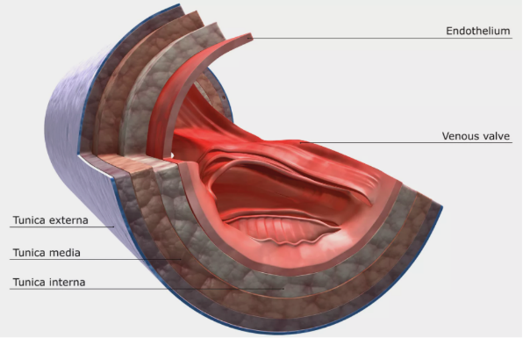

**Figure 3.1.1** Layers in vessels [1]

**3.2 Pulse Wave Velocity (PWV) and Pulse Transit Time (PTT)**

Our heart pumps blood in pulses to provide the oxygenated blood to every cell of the body also at same time have to accumulate deoxygenated blood form all body parts. In this process a pulse wave propagate through blood vessels and the velocity of wave is known as pulse wave velocity (PWV). As shown in fig 3.2.1 blood pressure increases pulse wave travels faster making pulse wave velocity (PWV) directly prerational to blood pressure

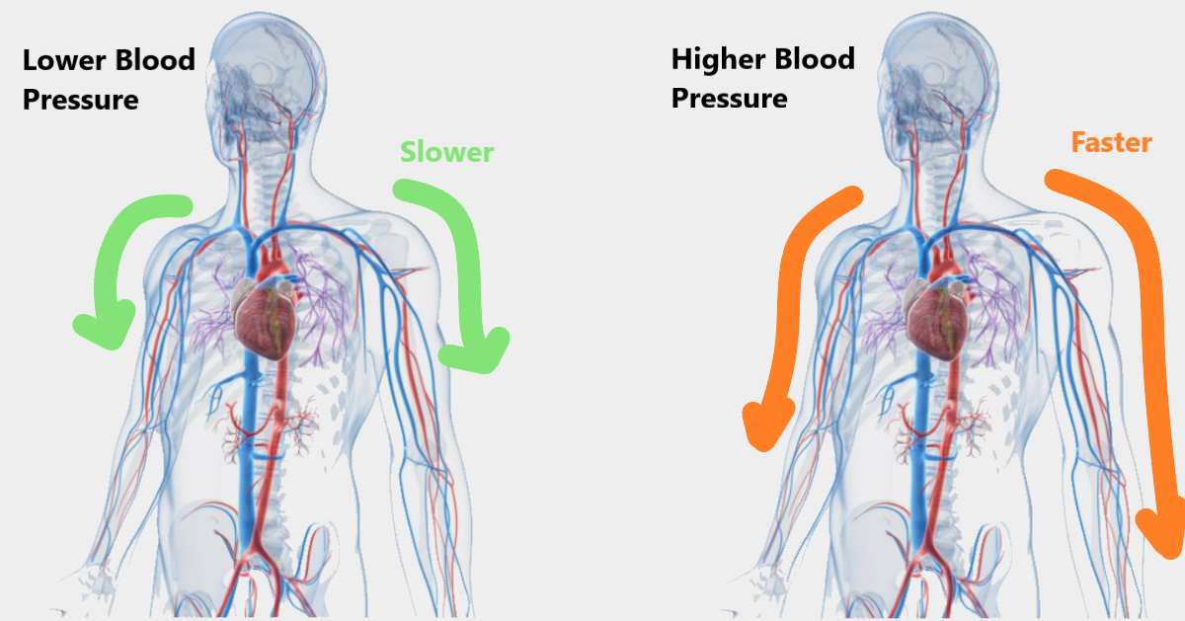

**Figure 3.2.1** Visualization of PWV [1]

PWV can be calculated using pulse transit time (PTT), where pulse transit time refers to the time a pulse wave needs to travel between 2 arterial sites. PTT can be calculated using pulse arrival time of 2 points using PPG sensors. For example, as shown in fig 3.2.2 to calculate this time we can place one photoplethysmogram (PPG) at elbow and one at wrist, one on wrist and one on tip of the finger from same hand. So that time difference between 2 pulse will be the pulse transit time.

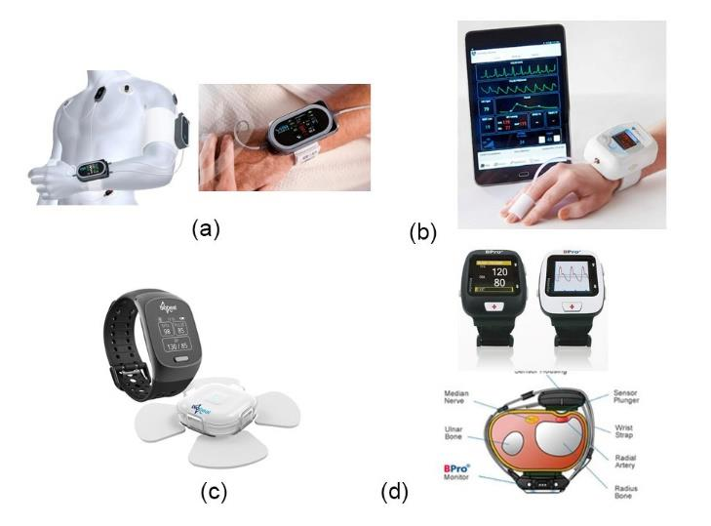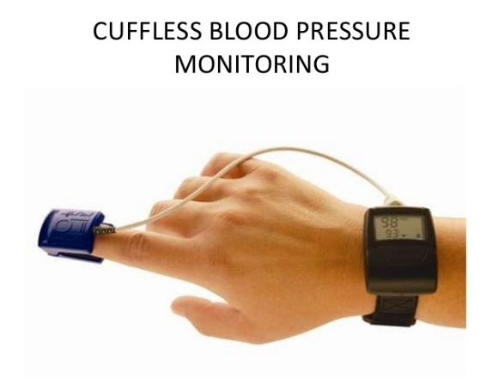 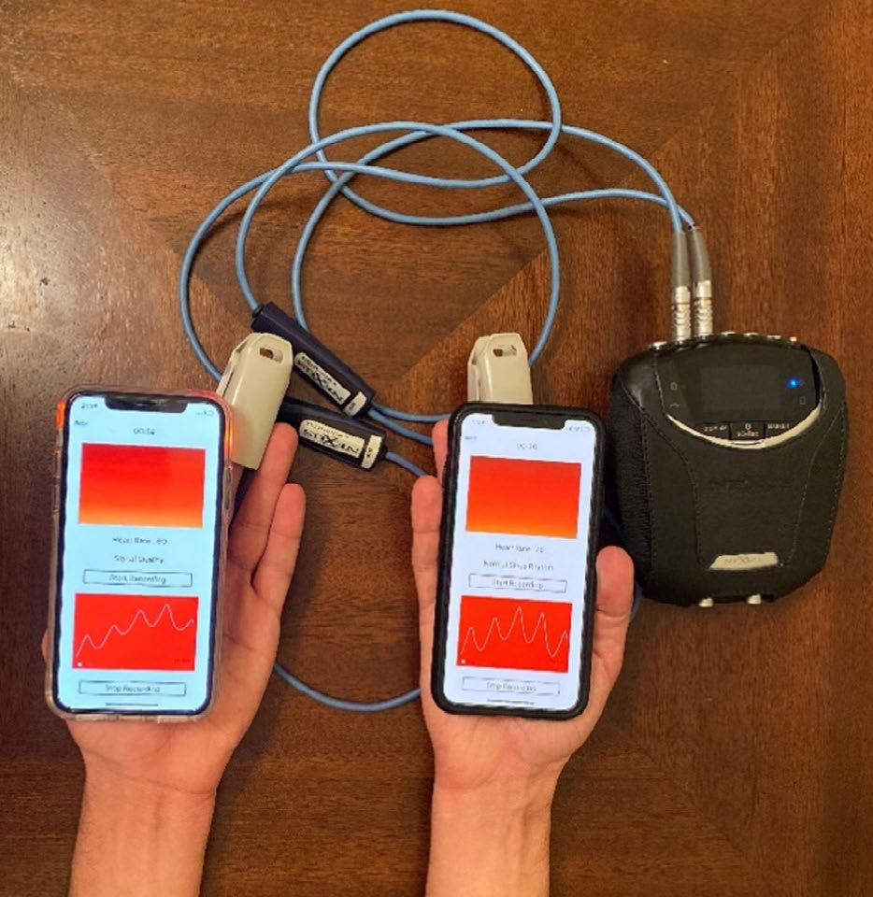

c)

b)

a)

**Figure 3.2.2** plcement fo PPG sensor, a) at elbow and writs, b) at wrist and finger, c) at 2 fingers of both hands [2],[3],[4]

**3.3 Working of PPG sensor**

Photoplethysmogram (PPG) is mainly consist of a light emitting diode (LED) and a photo detector. As shown in fig 3.3.1 a), PPG sensor is place at arterial site (where arteries also known as blood carrying vessels are most likely located). Where LED illuminates the are passing light through the blood and flesh which. The intensity of light gets detected by photo diode. Now, as pulse wave passes through density of blood changes and due to change in concentration of blood at the site intensity of light will also change. And this change will get detected by photo detector. The output of PPG can be seen in fig 3.3.1 b)

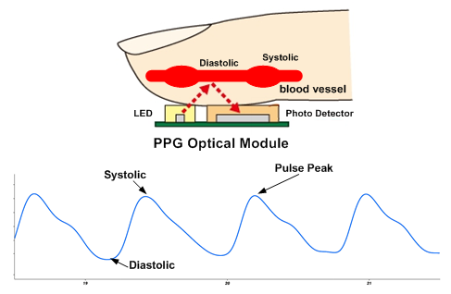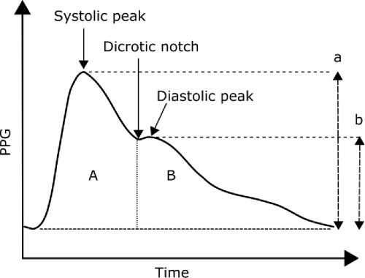

**Figure 3.3.1** a) working of PPG, b) standard output of PPG [5],[6]

**CHAPTER IV**

**METHODALOGY AND WORKING**

From 3 of the different placements of the PPGs we have discussed before, we have chosen to go with wrist and finger configuration. Not only it is more portable but also the length from wrist to finger is optimum to disfigured between to peaks and won’t be so unresolved either. We will talk about this in detail in further part of the report. And we will using Arduino for the processing as it already have multiple ADCs onboard.

**4.1 Flow of operation**

Our model will fallow the following steps for the BP estimation:

1. Collecting User inputs like data and when to start estimation
2. Collecting input from the PPGs located at wrist and finger at synchronous time
3. Converting PPG signal in to digital by using onboard ADCs of Arduino, as shown in fig 4.1.1
4. Calculation of PTT
5. **BP estimation**
6. Display and storing results

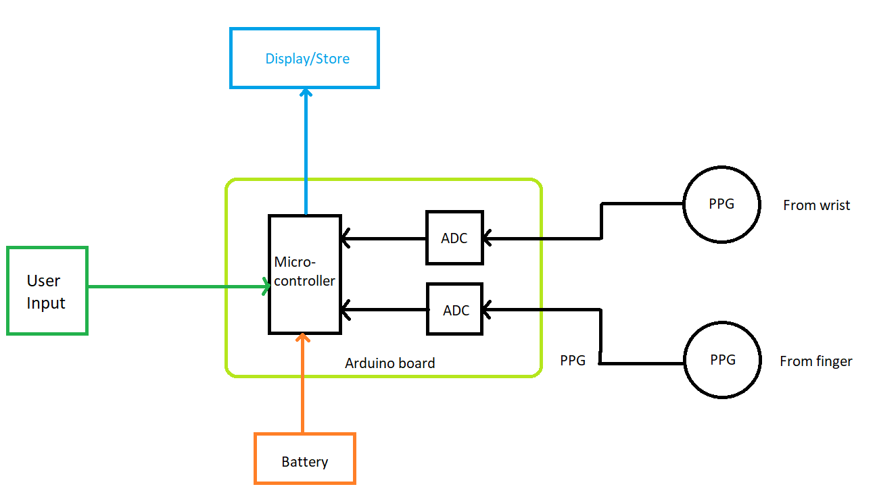

**Figure 4.1.1** Block diagram of proposed system

**4.2 Calculation of PTT**

As shown in fig 4.2.1 the R-wave in the ECG signal is the point where pulse wave is generates/starts propagating. The time taken by the pulse wave to reach certain arterial point is referred as pulse arrival time (PAT).

Hence there should be a time difference between PAT of wrist and PAT of finger which can be seen clearly in the figure. And the difference of both PAT will termed as pulse transit time (PTT) between wrist and finger.

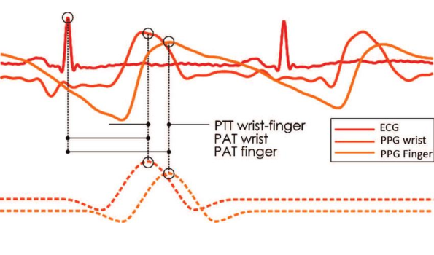

**Figure 4.2.1** PTT calculation based on the PPG waveform and ECG R wave [3]

However, it can also be calculated by time difference between 2 PPG peaks as shown in fig 4.2.2

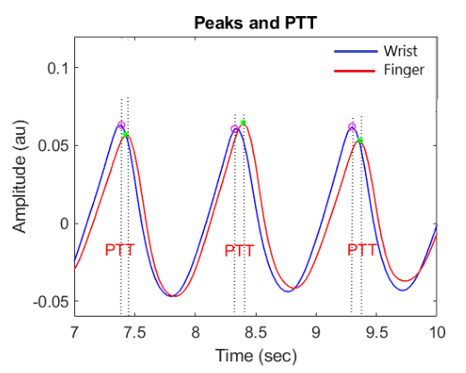

**Figure 4.2.2** PPT using PPG only

**4.3 BP estimation using PTT**

PTT is a physiological parameter defined as the time difference of the pulse wave moving between different parts of an arterial site. Studies have been done to relate BP to PTT value. Different mathematical models, such as linear and non-linear models, have been introduced to estimate BP from PTT values. For this purpose, the arterial vessels have been modelled using a tube with the elasticity characteristic of the arterial walls.

PTT is mathematically defined as [4]:

 (1)

where l is the arterial length, and L = ρ/A is a constant that represents the pressure difference in the arterial sites per the unit length, and is defined by the density of the blood (ρ) over the cross-section of the vessel (A). Here, C is a function of pressure P (blood pressure in the arterial site), which can be described as:

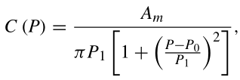 (2)

where Am, P0, and P1 are the physical parameters derived specifically, for each individual [52]. Thus, the BP estimation using the PTT should consider these individual specific parameters and should be calculated separately for each person for accuracy. It is shown that these parameters are related to the individual’s age, height, and other physiological parameters [4]. Considering these parameters and using equations

(1) and (2), the relationship between BP and PTT can be modelled as [4]:

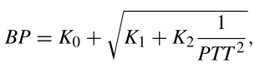 (3)

where K0, K1, and K2 are the individual-specific parameters. This non-linear model can be simplified into one of the most well-known models presented as a linear relationship between the BP of a test subject and the inverse value of PTT using the following equation [4]:

BP = K1PTT −1 + K2, (4)

where Ki’s are the unknown individual-specific parameters of the BP estimation model.

The BP values are described by the systolic BP (SBP) and the diastolic BP (DBP) values. The PTT −1 is the inverse value of the average of all the PTT.

**4.4 Calculation of constant Ki and BP**

We will be using graphical analysis method to calculate the constant Ki.

To keep it simple (This will decrease accuracy, but for experimental purpose) we’ll consider,

BP = K*PTT-1

Now to estimate constant K we will take number of readings colleting Actual blood pressure using cuff-based system, PTT using our model, Age, Height, and weight. As this constant is different for each individual but it wholly depends on age, height, weight and other such psychological parameters.

All this data will be plotted on graph and by connecting dots we will have all intermediate values and rough BP can be estimated. It can be visualized in fig 4.4.1 (this just prediction the actual direction depends on the real-world values)

**Figure 4.4.1** Chart: Changing blood pressure with changing height, weight and age

**CHAPTER V**

**DISCRIPTION**

Following are the components and their description which was been used.

**5.1 Arduino UNO R3**

**5.1.1 Introduction**

The Arduino Uno is an open-source microcontroller board Based on the Microchip Atmega328P microcontroller and Developed by Arduino.cc. The board is equipped with sets of Digital and analogue input/output (I/O) pins that may be Interfaced to various development boards (shield) and other Circuits. The board has 14 digital I/0 pins (six capable of PWM output), 6 analogue I/0 pins, and is programmable with Arduino IDE (Integrated Development Environment), via a Type B USB cable.

It can be powered by the USB cable or by an external 9-volt Battery. It also has 16 MHz ceramic resonators, a USB Connection jack, an external power supply jack, an ICSP (in circuit serial programmer) header and a reset button. It Operating voltage is 5v, input voltage 7 to 12v (limit up to 20v).

**5.1.2 Physical characteristics**

The maximum length and width of the Uno PCB are 2.7 and 2.1 inches respectively, with the USB connector and power jack extending beyond the former dimension. Four screw holes allow the board to be attached to a surface or case. Note that the distance between digital pins 7 and 8 is 160 mil (0.16”), not an even multiple of the 100-mil spacing of the other pins.

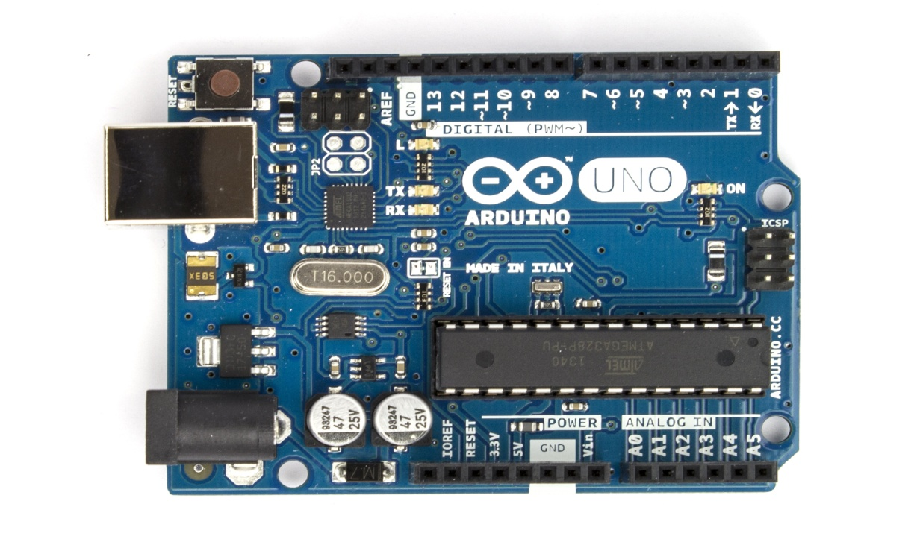

**Figure 5.1.1** Arduino UNO R3 front

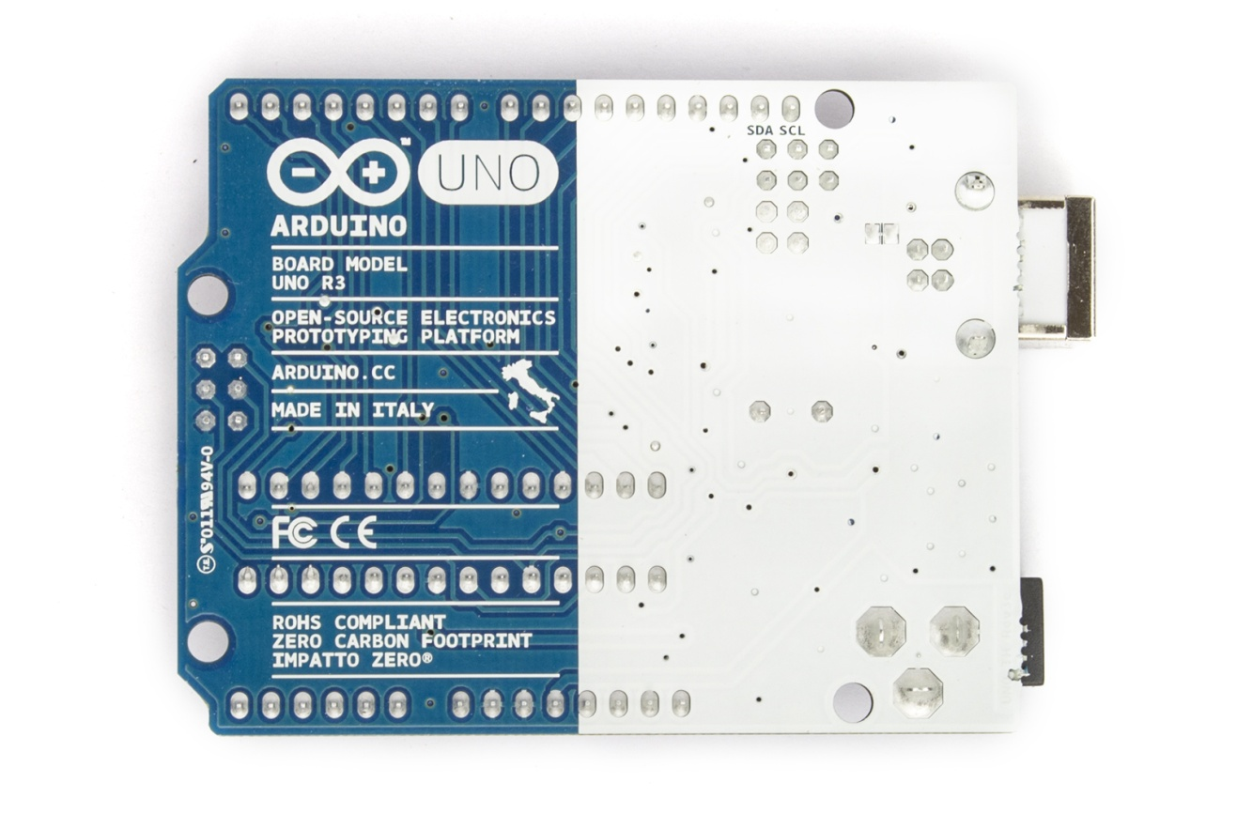

**Figure 5.1.2** Arduino UNO R3 rear

**5.1.3 Summary**

|  |  |
| --- | --- |
| Microcontroller | Atmega328 |
| Operating Voltage | 5V |
| Input Voltage (recommended) | 7-12V |
| Input Voltage (limits) | 6-20V |
| Digital I/O Pins | 14 (of which 6 provide PWM output) |
| Analog Input Pins | 6 |
| DC Current per I/O Pin | 40 Ma |
| DC Current for 3.3V Pin | 50 Ma |
| Flash Memory | 32 KB (Atmega328) of which 0.5 KB used by bootloader |
| SRAM | 2 KB (Atmega328) |
| EEPROM | 1 KB (Atmega328) |
| Clock Speed | 16 MHz |

**Table 5.1.1** summary of Arduino

**5.2 Photoplethysmogram (PPG)**

**5.2.1 Introduction**

A photoplethysmogram (PPG) is an optically obtained plethysmogram that can be used to detect blood volume changes in the microvascular bed of tissue. A PPG is often obtained by using a pulse oximeter which illuminates the skin and measures changes in light absorption. A conventional pulse oximeter monitors the perfusion of blood to the dermis and subcutaneous tissue of the skin. With each cardiac cycle the heart pumps blood to the periphery. Even though this pressure pulse is somewhat damped by the time it reaches the skin, it is enough to distend the arteries and arterioles in the subcutaneous tissue. If the pulse oximeter is attached without compressing the skin, a pressure pulse can also be seen from the venous plexus, as a small secondary peak.

The change in volume caused by the pressure pulse is detected by illuminating the skin with the light from a light-emitting diode (LED) and then measuring the amount of light either transmitted or reflected to a photodiode. Each cardiac cycle appears as a peak, as seen in the figure. Because blood flow to the skin can be modulated by multiple other physiological systems, the PPG can also be used to monitor breathing, hypovolemia, and other circulatory conditions. Additionally, the shape of the PPG waveform differs from subject to subject, and varies with the location and manner in which the pulse oximeter is attached.



**Figure 5.2.1** PPG sensor

**5.2.2 Features**

* Includes all the accessories for high-quality data acquisition
* Versatile form factor
* Embeddable into wearables
* Optical emitter and receiver
* Reflectance operating principle

**5.2.3 Applications**

* Life sciences studies
* Heart rate & heart rate variability
* Pulse transit time analysis
* Vasoconstriction effect detection
* Affective computing
* Physiology studies
* Biofeedback

**5.2.4 Finger placement**

Place the sensor at the centre of the Velcro fastening strap with its backside (circuit side) placed on the Velcro strap. Place your fingertip on the sensor, wrap the Velcro strap around your finger.



a) Placement b) PPG sensor fixation around the fingertip

**Figure 5.2.2** Finger placements

**5.2.4 Summary**

|  |  |  |  |
| --- | --- | --- | --- |
| |  | | --- | | Wavelength | | |  | | --- | | ~520nm (green) | |
| |  | | --- | | Consumption | | |  | | --- | | ~2.5-3mA | |
| |  | | --- | | Input Voltage Range | | |  | | --- | | 3.0 -5.5V | |
| |  | | --- | | Output Voltage | | |  | | --- | | 0.3 to VCC | |

**Table 5.2.1** summary of PPG

**5.3 LCD module**

An LCD module is been used to display the blood pressure and results. It also serves for the user interface purpose to collect the input from the user.

This is a 2 x 16 LCD display can be connected at

* LCD RS pin to digital pin 12
* LCD Enable pin to digital pin 11
* LCD D4 pin to digital pin 5
* LCD D5 pin to digital pin 4
* LCD D6 pin to digital pin 3
* LCD D7 pin to digital pin 2

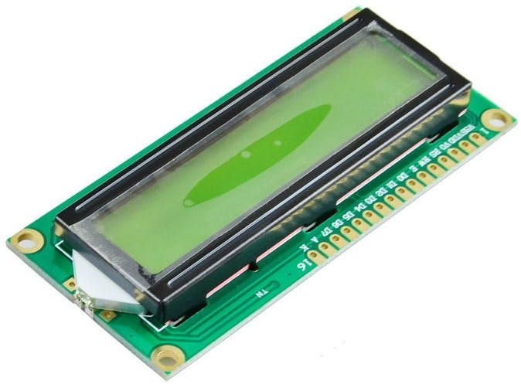

**Figure 5.3.1** LCD module

**5.4 Push buttons**

The model will be standalone device and to control menu driven program, we’ll use push button array. These push buttons works same as switches and can be programmed.

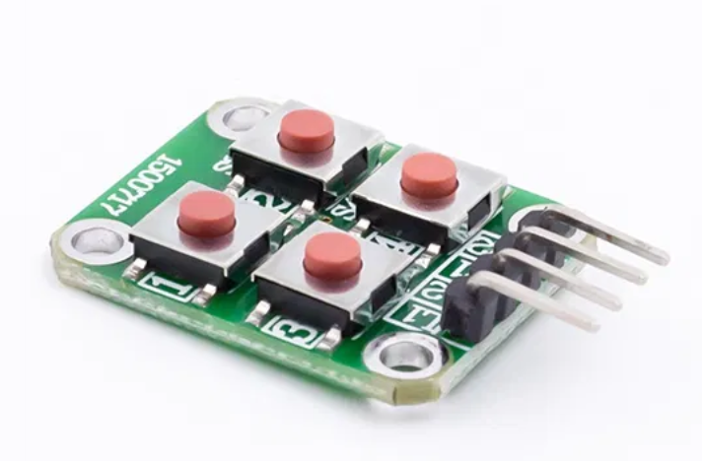

**Figure 5.4.1** Push button array

**5.5 Battery**

A 9 v battery will provide power to the Arduino and other parts. And using battery also make our model portable

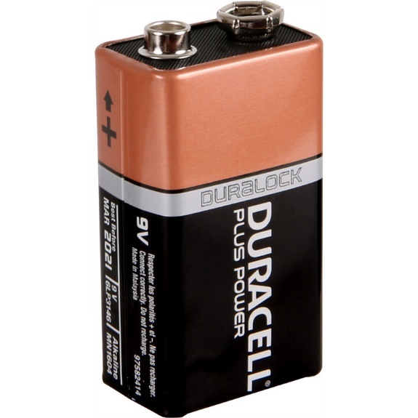

**Figure 5.5.1** Battery

**CHAPTER VI**

**EXPENDITURE INCURRED**

|  |  |
| --- | --- |
| **COMPONENTS** | **COST (IN RS)** |
| Arduino UNO board | 530 |
| PPG sensor X 2 | 270 |
| LCD module | 120 |
| Push button X 4 | 40 |
| Copper Wires | 50 |
| Bread board | 70 |
| Battery | 15 |
| **TOTAL** | 1095 Rs |

**Table 6.1** Expenditure table

\

**CHAPTER VII**

**SURVEY**

As our model focuses more on portability while losing some accuracy, but with best of our knowledge we believe it is enough for someone to do precautions before stroke.

For the same we have done an open survey to hear from people what is their opinion on the same.

**Survey results:**



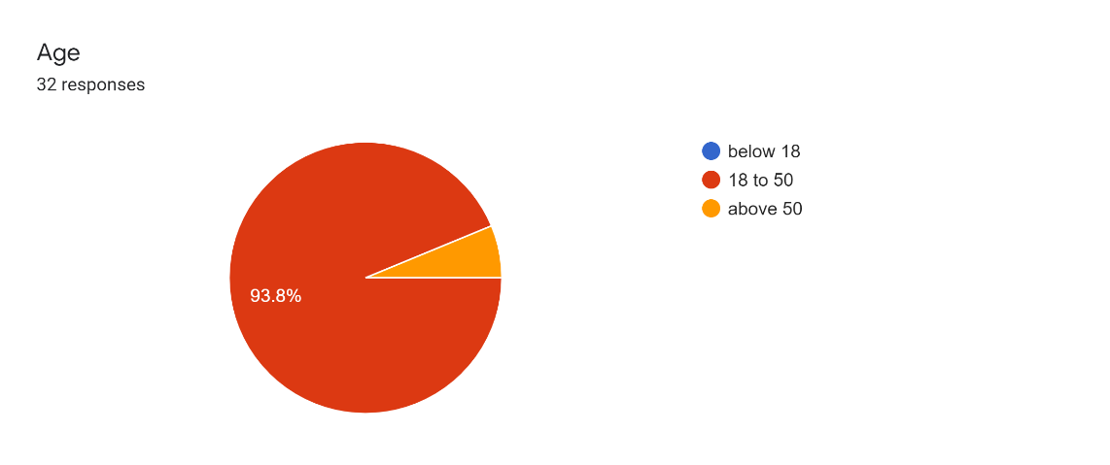

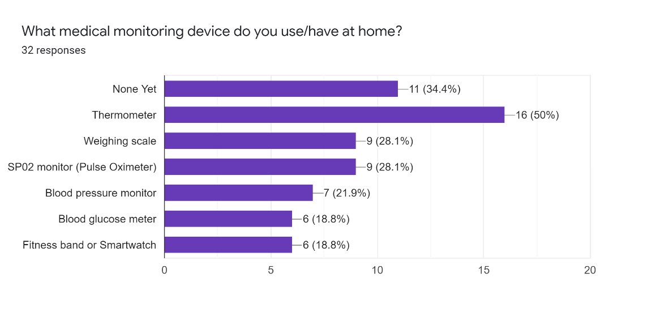



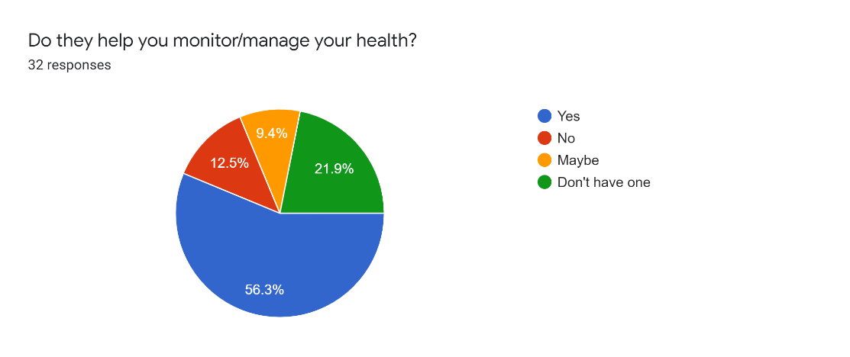

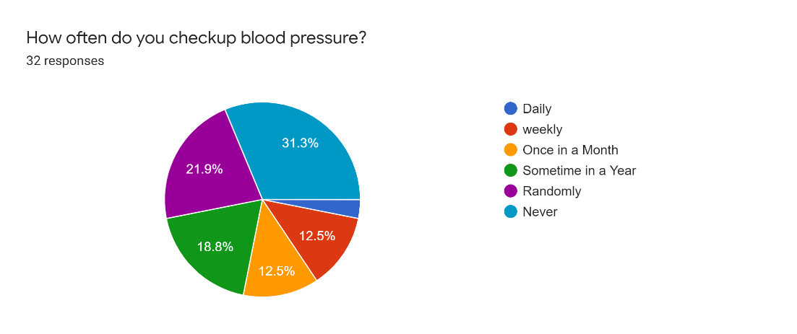

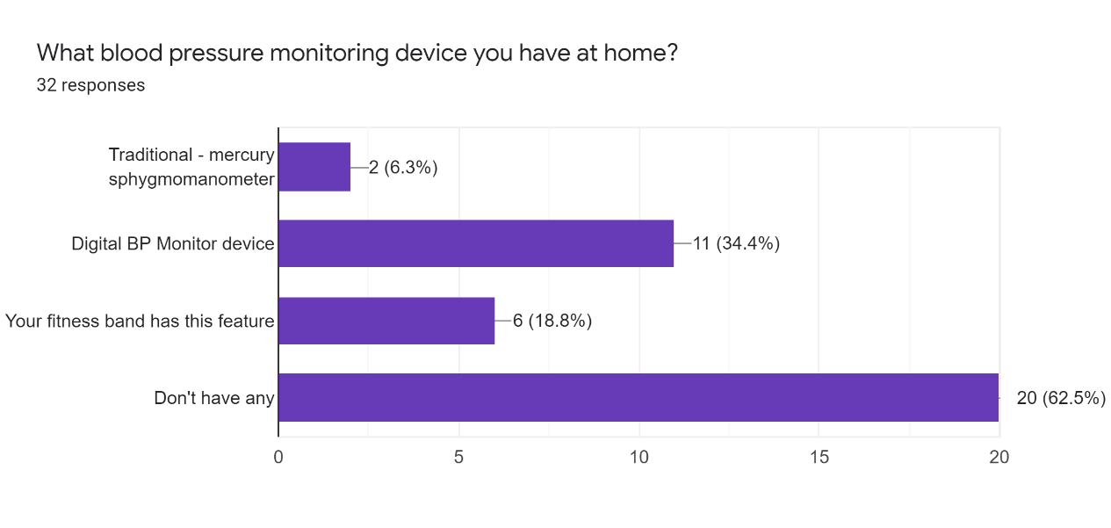



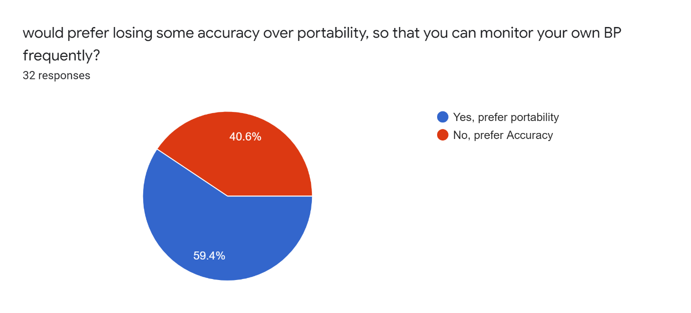

**Figure 7.1** Survey results

**CHAPTER VIII**

**ADVANTAGE, DISADVANTAGES AND**

**APPLICATION**

**8.1 Advantages**

* Cuff-less blood monitoring is technically comparable to standard cuff-based devices and provides various advantages for BP recording, such as more comfortable monitoring during a variety of life activities.
* Cuff-less blood pressure monitoring enables patients to share more accurate and reliable data of ambulatory BP monitoring with their physicians. Collectively, it is expected to lower the incidence of cardiovascular events by collecting BP data that are non-measurable by current diagnostic modalities.
* As extremely portable it can be included into wearable device using advance fabrication techniques.
* So easy to use that individual can monitor their own blood pressure.
* Though it is not very accurate (can’t take granted) but accurate enough to give a big idea before stroke or can prevent the progression of the hypertension and reduce medical costs.

**8.2 Disadvantages**

* Even very advanced devices could produce incorrect readings once in a while with certain individuals. That means you will need to regularly counter check your blood pressure with conventional blood pressure monitors in your hospital.
* Cuff-less blood pressure monitoring devices usually very sensitive and expensive.
* Cuff-less blood pressure monitoring devices are often delicate devices that require careful handling.
* Repairing them is quite difficult.

**8.3 Application**

* Implantation in wearable tech:

Measuring blood pressure using cuff-less sensor in healthcare devices or smart-phones.

* Portable live BP monitoring:

24X7 Continuous monitoring in hypertension patient can be done by cuff-less monitoring.

* In using embedded system using GSM module we can stoked patient by auto generating massage system to ambulance & medical hospital consultant.
* Can used to produce simple, easy to use commercial product to monitor individual’s personal health

**CHAPTER IX**

**CONCLUSION AND WORK SCHEDULED**

**FOR PHASE – II**

**9.1 Conclusion**

From the proposed system we can conclude that a cuff-less BP monitors, which show promise for healthcare applications, were described. However, more detailed and precise evaluation of these devices is needed to confirm their clinical efficiency. we hope that this cuff-less blood pressure monitoring device will be handful for user who are suffering from hypertensions, hypotension or BP related diseases to monitor their BP regularly at home.

**9.2 Future scope**

**1**. unlike others our model focuses on calculating physiological constant using different physiological parameters using graphical analysis. But same can be done using machine learning model which then we can use in *raspberry pie*. This will not only increase the accuracy but also allows us to add a greater number of physiological parameters.

**2.** Currently smart watches and fitness bands are widely being used. Also, the emerging technology called smart rings being introduced to market. We belie using advanced fabrication techniques our model can be implemented in wearables.

Same model can be then replaced with as represented in fig 7.1.1

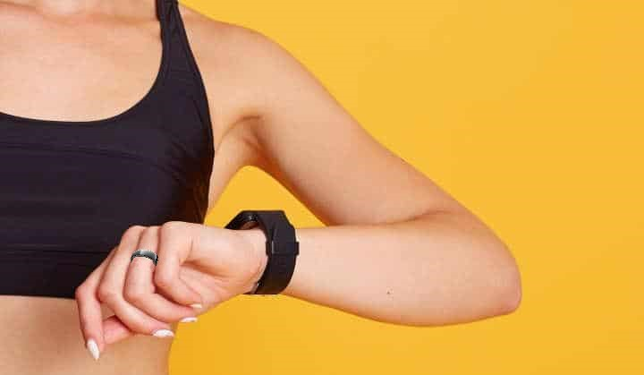

**Figure 9.2.1** Smart ring and smart watch

**REFERENCES**

[1]. How Veins Transport Blood, Available: <https://www.thoughtco.com/vein-anatomy-373252>

[2]. <https://www.slideshare.net/vipsi93/cuffless-blood-pressure-monitoring-project>

[3]. Toshiyo Tamura, “Cuffless blood pressure monitors: Principles, standards and approval for medical use”, in IEICE Transactions on Communications · December 2020

[4]. Fatemehsadat Tabei, Jon Michael Gresham, Behnam Askarian, Kwanghee Jung, Jo Woon Chong, “Cuff-Less Blood Pressure Monitoring System Using Smartphones”, IEEE, Digital Object Identifier 10.1109/ACCESS.2020.2965082, VOLUME 8, 2020

[5]. Output of PPG: <https://www.osapublishing.org/boe/fulltext.cfm?uri=boe-10-9-4353&id=416423>

[6]. ECG/PPG measurement solution: https://www.richtek.com/Design%20Support/Technical%20Document/AN057